01/02/18

When first playing with the Lab, I was instantly fascinated with playing with sticks in Venice.

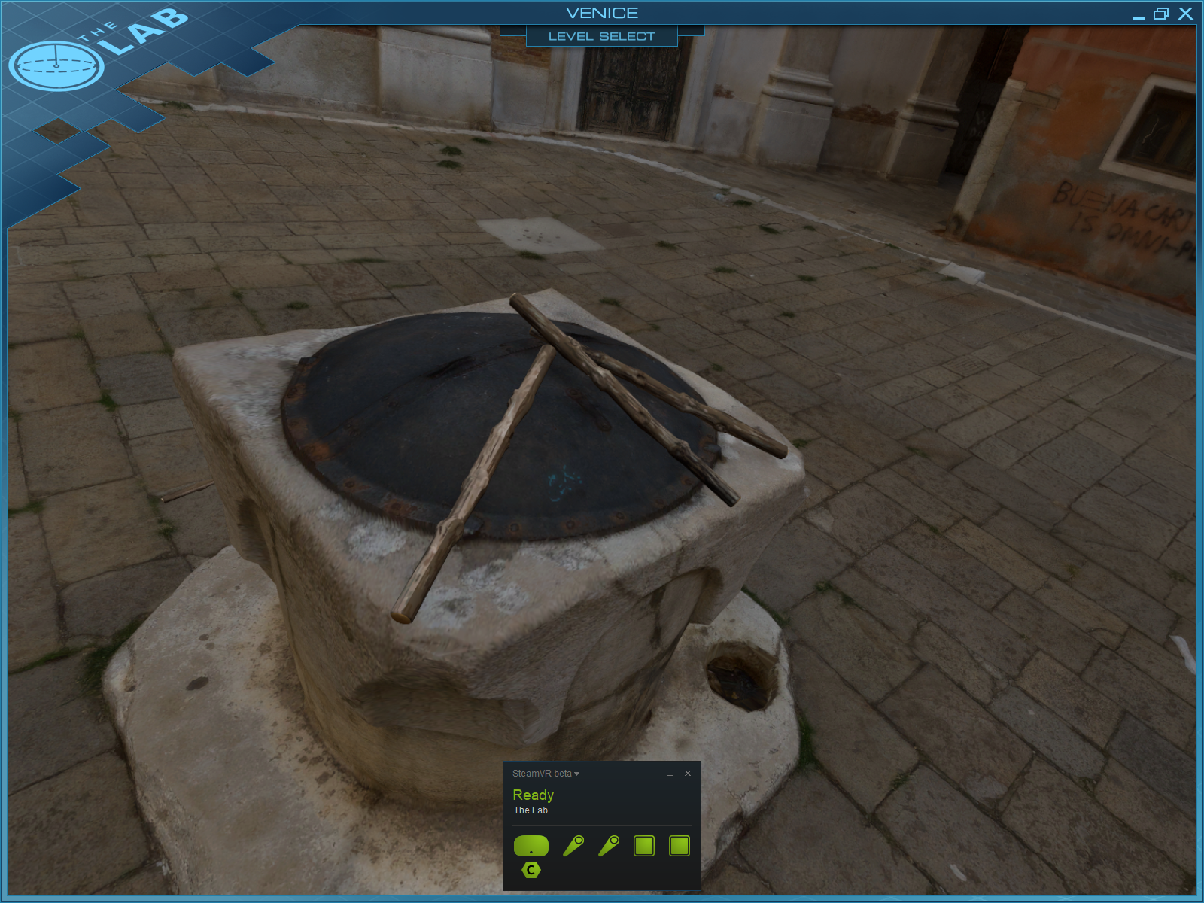

The worst part was… there was nothing to do with them.

Well that is a lie, there is a cute little dog who will fetch the sticks once you have thrown them.

The sticks will also react to the environment once released from your hand, so have a satisfying *smack* as they hit the walls and floors on the Italian city.

But what I **REALLY** wanted to do with them was bang them myself onto this centre statue holder in the centre of the plaza, like a rebellious drum kit. But alas, that was not the case.

When holding the sticks, the collision on them completely disappears, you cannot bash one into another on the floor, or one on the other hand, or onto a structurer within your reach, for any sense of collision to exist, you must release the grip.

This gives me my first idea for an education virtual reality tool that I instintivly wanted to exist, “DRUM KIT VR”, so I looked to see if anything existed which met what I had in mind, a guitar hero esc drum playing tutorial slash playspace.

I found a few, notably:

Drummer Talent VR: <http://store.steampowered.com/app/609170/Drummer_Talent_VR/>

Drums Hero: <http://store.steampowered.com/app/608370/Drums_Hero/>

Drums Hero in particular looking exactly like I imagined a polished version of the prototype in my head ending up like.

So if a gamified drumming game existed, what other possible options existed?  
Well they didn’t seem very “Educational” in nature, with focus solely on the guitar hero style hit the note as it flies at you gameplay.

Perhaps to differentiate what I was doing, I could have a more formal test of drumming ability, with “real” musical notes, sheets of music, or playing from memorisation without the use of coordinated game points to hit as a goal.

Imagine playing “drum hero” with the colours flying at you turned off? Now that sounds difficult, but more accustom to playing the real guitar. Suppose I implement drum hero with some simple songs, and remove the visual indicators for what to drum, leaving it all up to the user to play blindly, before applying a score at the end tracked in the background AS IF the timings had to be met.

As someone with no official musical teachings or a history of playing the drums, I would consult some music students and ask for advice on beginner songs to work on in the app, so I know I have a good starting song to work on.

I also played with a bunch of other stuff in the lab, almost everyting

Medical thing was super underwhelming, kinda sucked honestly. Neat concept with the square to remove bits of body though

Slingshot was super fun, had a real valve charm to it

Bow and arrow is exactly as expected… the mechanism for putting the arrow into the bow was nice thought, where within a certain range of the bow controller it starts an animation to automatically slide in, so you don’t have to be very precise.

02/02/18 Portal Stories: VR

This was a short puzzle game, revolving around the order you place cubes on buttons, and re-orient lasers with special cubes. No Portals sadly.

The moving was slightly different to previous experiences, with you first having to hold down the left pad, before pulling the trigger to activate the teleportation.

This allowed for more deliberate movement, especially the ability to cancel doing a move by just not pulling the trigger.

Using the physical space to duck, in order to avoid incoming turret fire was a really fun and engaging experience, which really immersed me despite trying to keep a critical eye out for interaction methods. I must say I was totally lost in the instance where I had to physically move to engage with the medium, and will consider this increased immersion in the development stage.

No Limits 2 Roller Coaster Simulation Demo

The most immersive experience I have had, and it was a seated VR experience.

Everytime it turned a corner I tilted my head to match, I was physically forced to!

It was a fight in order to stay upright, and that was only on the beginner wooden coaster, not even a hardcore high speed with flips.

No methods of interaction, just an experience, so not much to take away for my own game

08/02/2018

The idea of throwing objects with different starting momentums

So shooting in basketball while being propelled upwards.

Or bouncing on a trampoline

Or falling fast

Coming in sideways really fast.